**Mindfulness, Creative Movement, & Relationships**

**Free One Hour Zoom Seminar at 7:30 PM EST**

**Monday, April 04th Wednesday, May 11th Thursday, June 16th**

**Link to Zoom** [**Meeting ID: 9172420544**](https://us02web.zoom.us/j/9172420544) **(No Password)**

Experience a powerful state of tranquility, balance, & centering as Dr. Pat Webbink combines

Guided Imagery & Music, Creative Movement, and Dance with her Theory of Relationships.

She has authored 3 books on relationships, & a book on eye contact and intimacy, & all about eyes.

Dr. Pat is a licensed psychologist & acclaimed pioneer in the use of mindfulness,

deep relaxation in psychotherapy. A multilingual world traveler, she combines

50 years of experience as a clinician with the practice of meditation in therapy.

She and her colleagues work with children, adolescents, couples, families, and groups.

***Hear her recordings by clicking images below. Also available on CD or through Bandcamp.com***

[](https://patwebbink.bandcamp.com/track/centering-1)[](https://patwebbink.bandcamp.com/track/healing-childhood-trauma-5)[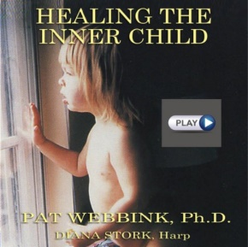](https://patwebbink.bandcamp.com/track/healing-the-inner-child-4)[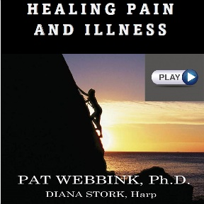](https://patwebbink.bandcamp.com/track/mindfullness-8)

[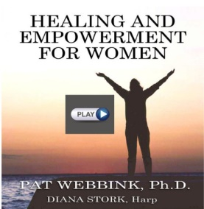](https://patwebbink.bandcamp.com/track/healing-and-empowerment-for-women-11)[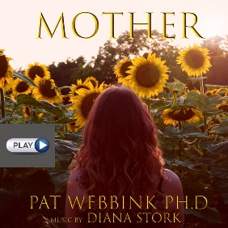](https://patwebbink.bandcamp.com/track/mother-10)[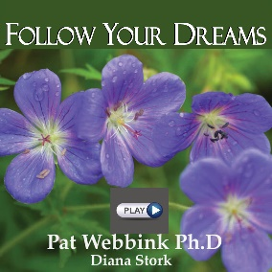](https://patwebbink.bandcamp.com/track/follow-your-dreams-9)[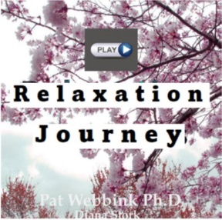](https://patwebbink.bandcamp.com/track/relaxation-journey-13)[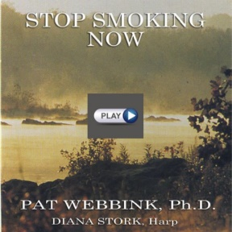](https://patwebbink.bandcamp.com/track/stop-smoking-now-7)[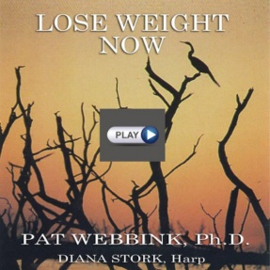](https://patwebbink.bandcamp.com/track/lose-weight-now-6)[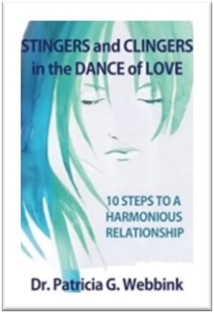](https://aaccounseling.com/stingers-and-clingers-in-the-dance-of-love/)[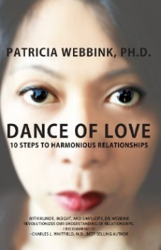](https://aaccounseling.com/dance-of-love-10-steps-to-harmonious-relationships/)[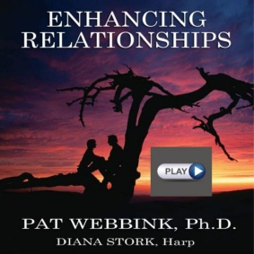](https://patwebbink.bandcamp.com/track/enhancing-relationships-12)[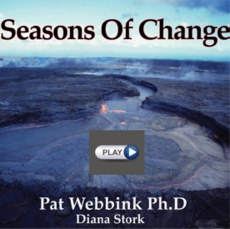](https://patwebbink.bandcamp.com/track/seasons-of-change-15)[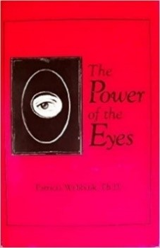](https://aaccounseling.com/the-power-of-eyes/)[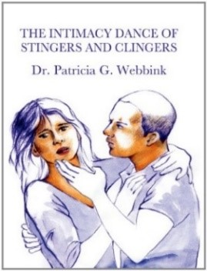](https://aaccounseling.com/the-intimacy-dance-of-stingers-and-clingers/)

**Discounted Books available through Dr. Webbink**

***Click on images below***

**Contact Dr. Pat Webbink for a Free 15-minute session**

[**301-229-8000**](tel://301-229-8000/) **or** [**PatWebbink@aol.com**](mailto:PatWebbink@aol.com)